ROODYLIB

Table of Contents
Introduction and Acknowledgements 4
Getting Started 5
Starting Fresh 5
MakePlayer 5
Completely New to Hugo? 5
Updating an Older Game to Roodylib 6
Presentation 7
Status Lines 7
PrintStatusLineLocation 8
Custom Status Fields 8
Room Descriptions 8
PrintRoomName 10
“Relative Descriptions” 10
Alternate Dark Room Behavior 11
Clearing the Screen 13
Accessibility 13
Hugolib Object Class Improvements 14
Attachables 14
Characters 14
Checkheld Objects 15
Containers and Platforms 15
Enterable Containers and Platforms 15
Holding property 15
Doors 15
Rooms 16
Vehicles 16
Parsing 17
extra_scenery 17
Disambiguation Helper 17
Preparse 18
OrdersPreParse 19
preparse_instructions objects 19
Pronouns 20
AssignPronoun 20
ParsePronounFix 20
ExcludeFromPronouns 21
Game Loop 22
main_instructions 22
NO_LOOK_TURNS 22
Scripting 23
Game Messages 24
AMERICAN_ENGLISH 24
AUTOMATIC_EXAMINE 24
CoolPause 24
TopPause 25
RoomSounds(location) 25
DoVersion / GameTitle 26
Standard Message Replacement 27
Resources 28
CheckResourceMusic 28
CheckResourceSound 28
CheckResourceGraphic 28
Resource Treatment in Gargoyle 28
HugoFix 29
OrganizeTree 29
Recording Playback Helper 30
Finishing Touches 31
Ending the Game 31
CallFinish 31
SpecialKey / SpecialRoutine 31
QuitGameText 32
BETA system 32
Other Features 33
The New Opcode System 33
Using the Opcodes 33
Opcode object classes 34
fade_screen 34
set_color 35
Contact and Future Additions 36

Introduction and Acknowledgements

Welcome to Roodylib! Roodylib exists to improve upon and fix some things in the original Hugo library and to hopefully add some extra functionality while we’re at it. Roodylib would not exist without the contributions and suggestions from Kent Tessman, Mike Snyder, Jason McWright, Robb Sherwin, Rob O’Hara, Paul Lee, Juhana Leinonen, Nikos Chantziaras, and Tristano Ajmone.
Additional tsunamis of thanks go to Paul Lee for his invaluable suggestions for this document. The tiniest raindrop of gratitude goes to Marius Müller for his one suggestion.
Written with LibreOffice.

This work is licensed under the Creative Commons Attribution-NonCommercial-ShareAlike 4.0 International License. To view a copy of this license, visit http://creativecommons.org/licenses/by-nc-sa/4.0/ or send a letter to Creative Commons, PO Box 1866, Mountain View, CA 94042, USA.

Getting Started

First off, a note about flags (such as USE_ROODYLIB, USE_DARK_ROOM, or any of the other ones listed in this document): you'll always want to #set them before any grammar or library files are included. If you're using the Roodylib “new shell”, you can set all flags in flags.hug; otherwise, you really can just put them before any libraries are included.

Starting Fresh
Starting a new game? The best way to jump right in is to use one of the game stub files from the “shells” folder. The one in the “old” folder is one file with some of the most used switches and file inclusions available, while the one in the “new” folder splits all that up into several files. It’s my intention that the new shell is a good start for a larger, more-complicated game where organization is important.
You’ll want to make sure the #set USE_ROODYLIB line is not commented out—I believe that’s the default—but I include the option to turn Roodylib off to make it easier to track down if a bug is due to Roodylib code.

MakePlayer
Especially if your game is not in the usual second person, you might want to be aware of MakePlayer, a helper routine for setting up the player character object.
MakePlayer(<player character object>, <tense number>)

So, in a regular, second-person game where the player character is defined as the you object, you would call MakePlayer(you,2). Besides setting the player variable, the routine also sets the location variable to the parent of the player (which Roodylib will still interpret correctly if it happens to be an object in a room).

Completely New to Hugo?
If you are just starting out with Hugo and are using Windows, I recommend using my Hugo & Notepad++ bundle. Notepad++ is a highly-configurable text editor, and I’ve prepared it with syntax highlighting and toolbar buttons for easy file-creation and compilation (among other things). You can get it here.

Updating an Older Game to Roodylib
Of course, the most important thing is to include Roodylib itself. To do this, you want to #include “roodylib.g” before verblib.g and #include “roodylib.h” after hugolib.h. Beyond that, you’ll want to call the routines Init_Calls in the init routine and Main_Calls in the main routine.
routine init
{
!: First Things First
SetGlobalsAndFillArrays
!: Screen clear section
#ifclear _ROODYLIB_H
cls
#else
InitScreen
Init_Calls
#endif
!: Game opening
IntroText
MovePlayer(location)
}

routine main
{
counter = counter + 1
run location.each_turn
runevents
RunScripts
if parent(speaking) ~= location
speaking = 0
PrintStatusLine
Main_Calls
}
example init and main routines

If you’re using any additional extensions that make use of Roodylib functionality, it’d be good to #set USE_ROODYLIB before any files are included.
Roodylib adds a lot of extra routines so it’s likely you’ll have to raise your routine limit settings. To do this, add this to the beginning of your code:
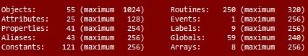 a Roodylib shell file compiled with the Roodylib library included
$MAXROUTINES = [new limit]
raising the maximum number of routines
Depending on your game, you may need to change other limits as well (all are covered in the Hugo Book). Basically, if the compiler complains that you have gone over the limit for any particular thing, just keep raising the number of the max allowed until it works!

Presentation
One of the biggest features Roodylib provides authors right out of the box is its attention to presentation.

Status Lines
If you are new to IF, we refer to the top line of the window (the one that displays the room name and possibly a score and/or turn counter) as the “status line.” In recent years, I’ve been disappointed with the attention given to status lines in many games. We may have moved past keeping score in many games, but I find the unmarked turn counter in some games a bit distracting.
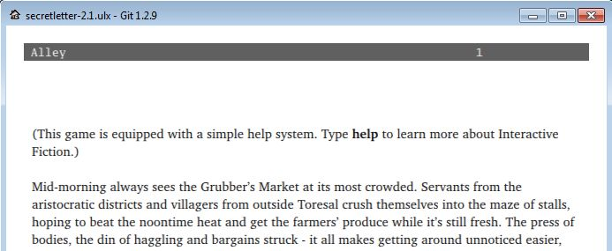

The score counter is not even in an eye-pleasing location. No matter what you kind of information you want in status bar, this is something Roodylib will do automatically.
In Hugo, you select the status line type you want by changing the STATUSTYPE global. To make this simpler, I’ve set up some constants you can use for setting your status line type.
NO_STATUS | No information displayed in top right
SCORE_MOVES | The abbreviated score/turn counter popular today (“0/0”)
TIME_STATUS | Display turn counter as converted to clock time (“9:00 am”)
CUSTOM_STATUS | Use the routine STATUSTYPE4 to print the status
INFOCOM_STYLE | Print the old long version of score/turns (“SCORE: 0 TURNS:0”)
MILITARY_TIME | Display turn counter as clock in military time (“22:00”)

To select the status type you want, just put a line like this in init or SetGlobalsAndFillArrays (depending on whether you are using one of the Roodylib shells):
STATUSTYPE = INFOCOM_STYLE

PrintStatusLineLocation
Roodylib now uses a dedicated routine for printing the room name in the status window.
routine PrintStatusLineLocation
{
if not location
print "\_";
elseif not light_source
print "\_In the dark";
else
{
print "\_";
print capital location.name;
}
}

This can be easily replaced if there are instances where you want different behavior.

Custom Status Fields
If you set STATUSTYPE to the CUSTOM_STATUS constant, replace the STATUSTYPE4 routine to print your status information how you would like to see it (by “status information,” I only mean the information in the top right side of the status window, where the score/turn count would normally go). This makes it easy to provide other kinds of information in your status line, such as moods, health, or whatever else you can think of.
replace STATUSTYPE4
{
local a
select player.mood
case 4 : a = "Happy"
case 3 : a = "Bothered"
case 2 : a = "Distraught"
case 1 : a = "Absolutely Crushed"
print a;
}

Any colors you use in STATUSTYPE4 will be properly displayed, too.

ExtraWindows
PrintStatusLines now calls an empty routine called ExtraWindows. If your game has additional windows for graphics or anything else, you can replace ExtraWindows and have it call the routines that create them, ensuring that the windows are updated after every turn.

Room Descriptions
Roodylib also offers a variety of options for how room description text is presented. Like the original Hugo library, some of these settings are determined by the FORMAT global variable and whatever masks you apply to it, with a command like the following in init or SetGlobalsandFillArrays:
FORMAT = FORMAT | (mask constant)

All of the available FORMAT masks are listed in the Hugo Book (and hugolib.h), but I think the ones most likely to be used by authors are:
LIST_F | Contents of objects are given “tall” lists instead of listed in sentences (so, Zork style)
NOINDENT_F | If you disagree with Hugo’s indentation style, this is a quick way to turn it off.
DESCFORM_F | This puts an extra new line in between a room’s description and its contents.

Roodylib slightly changes the behavior of how games that use that LIST_F mask look, but for the most part, you don’t need to worry about any of that. Roodylib also adds a DESCFORM_I mask. If this is used, the DescribePlace routine does not automatically print a new line before a room description is printed.
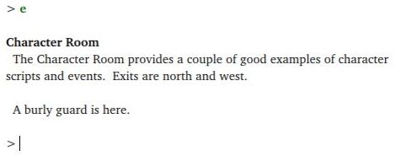 FORMAT = FORMAT | DESCFORM_F

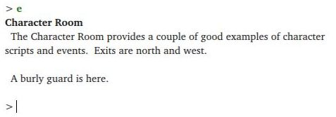 FORMAT = FORMAT | DESCFORM_F | DESCFORM_I

PrintRoomName
Roodylib also now provides a routine for printing the location name in the current room description.
routine PrintRoomName(a)
{
if not (FORMAT & DESCFORM_I)
print ""
else
print newline
Font(BOLD_ON)
print capital a.name;

! Print ", in <something>" if necessary
if location = a and player not in a
{
if parent(player).prep
print ", "; parent(player).prep; " ";
elseif parent(player) is platform
print ", "; ON_WORD; " ";
else
print ", "; IN_WORD; " ";
print Art(parent(player))
}
print newline
Font(BOLD_OFF)
}

Again, this is for ease of use. If authors want any different behavior (like added colors or more control over preposition usage), they won’t have to dig too deep into DescribePlace figuring out how they should do it.

“Relative Descriptions”
Roodylib has an option for special treatment when the player is inside a container in a room. To use it, just #set USE_RELATIVE_DESCRIPTIONS in your code before Roodylib is included.

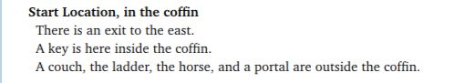 example of “relative description” generated text
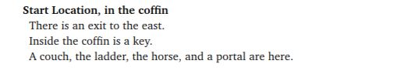 the same room without relative descriptions
The above works automatically if the parent of the player is a container, but platforms are ignored by default (if the player is sitting on something like a chair, you wouldn’t want everything else described as “off” the chair). Still, there may be a platform instance where you would want the “relative parent” behavior. To do this, first replace the RelativeParent routine to allow for the object you want it to work for:
replace RelativeParent(obj)
{
if player not in location and parent(player) is container
return true
elseif parent(player) = monkey_bars
return true
else
return false
}
replacing RelativeParent
And then you replace the RelativeText routine to print whatever text you want for objects that do or do not share the same parent as the object in question:
replace RelativeText(obj)
{
if obj = location and player not in location
{
if parent(player) = monkey_bars
print "off ";
elseif parent(player) is container
print "outside ";
}
elseif obj is container
print "inside ";
else
print "on ";
The(parent(player))
}

Alternate Dark Room Behavior
Ok, not many games these days even have dark rooms, but somewhere along the way, I decided I didn’t like the way dark rooms are handled in Hugo. Even though its behavior was based on classic games such as Zork and Adventure, I found it disorienting the way that dark rooms almost feel like non-rooms. I figured it’d be cool to make it look more room-like, so I added an option for this. To use it in your game, #SET USE_DARK_ROOM before roodylib.h is included.
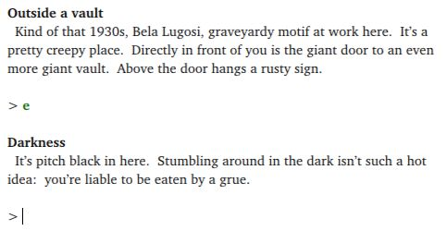with USE_DARK_ROOM

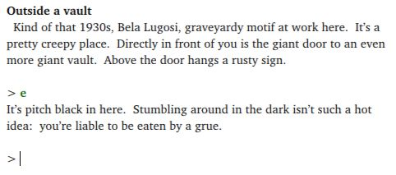default behavior

If you are using the USE_DARK_ROOM option and would like to configure any of its behavior, you can do the following:
- If you’d like to change the darkness “room” name, change darkness.name to the text of your choice ( darkness.name = “OMG Can’t See Anything”) somewhere like init or SetGlobalsAndFillArrays. Alternatively, you could replace the darkness object and give it a new name that way.
- If you’d like to change the rest of the text, as before, replace the DarkWarning routine:
replace DarkWarning
{
PrintRoomName(darkness)
Indent
print CThe(player); " stumble"; MatchSubject(player); \
" around in the dark."
}

Clearing the Screen
Roodylib has a few routines for making screen-clearing consistent and cool-looking. Personally, I prefer when IF games’ text is drawn from the top of a window down. Roodylib tries to mimic this look by moving the cursor whenever the screen is cleared using one of its functions. Some routines like PictureInText pretty much depend on the cursor being at the bottom of the screen, though. In such a game, you’d want to force the game to always keep the cursor at the bottom. You do this by replacing the LinesFromTop routine.
replace LinesFromTop
{
return display.windowlines
}

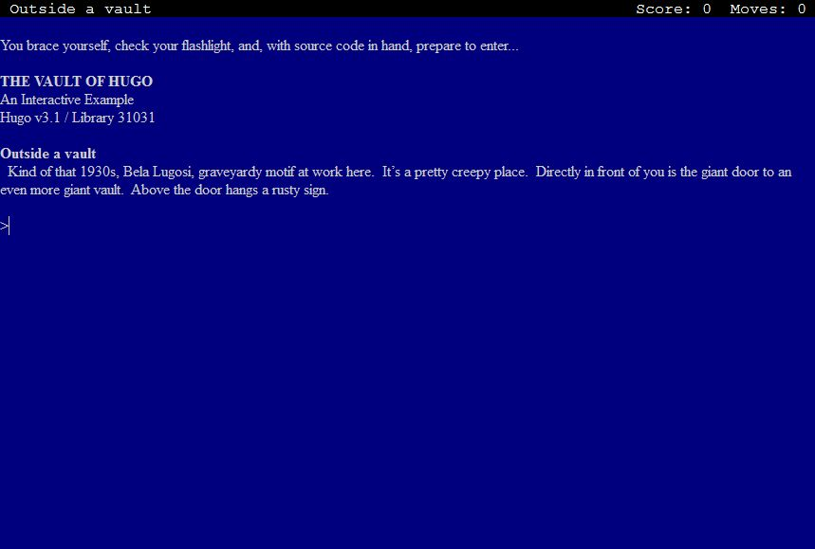 default LinesFromTop value
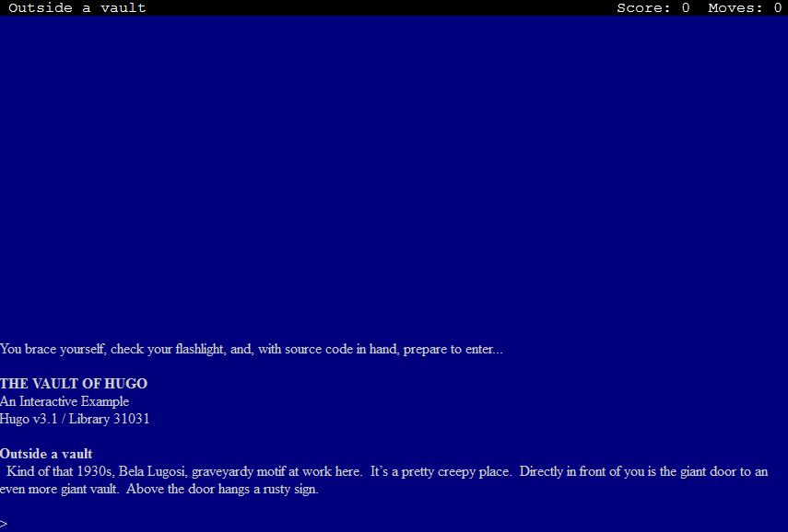 replaced LinesFromTop

Calling the InitScreen routine will completely clear the screen (getting rid of any existing windows), moving the cursor to wherever LinesFromTop determines it should be. The ClearWindow routine, though, only clears the current window (and then moves the cursor). This is for instances where you don’t really need to redraw everything—just the current window.

Accessibility
While it shouldn’t affect most of you as authors, be aware that Roodylib has some accessibility features, like the ability to change the prompt to a “Your command….” phrase or to disallow screen-clearing (and forcing numerical menus as long as “newmenu.h” is used).

Hugolib Object Class Improvements
I imagine one thing people will want to know is how Roodylib changes any object class behavior. Let’s go cover some!

Attachables
One thing that Roodylib does differently is it lists attachables held by the player but attached to something in the room in the room description. If the “new DescribePlace” system is on, it also changes when regular attachables are listed in the room description.
Roodylib has support for rollable objects— those that can be pushed from room to room. (I use the term “rollable” because I always think of the giant onion from Beyond Zork, but the concept applies to really anything that can be moved.) Roodylib’s attachable code has been updated to accommodate such scenarios where an attachable is connected to a rollable object.

Characters
In Roodylib, characters are automatically excluded from “all” commands (like >GET ALL). Additionally, while the Hugo library has always allowed for taking objects from friendly characters, in Roodylib, that gets its own message (“so-and-so allows you to take the <blank>”), whereas before it was just “Taken.”
If you want to disallow taking items from friendly characters, stop it with a “parent(object) DoGet” before routine on the character object.
Roodylib’s default also allows for >GET ALL FROM <character>. To disallow that, replace the ExcludeFromAll routine so it always returns true when the parent is living. You'll also want to provide NewParseError case 9 with a special message that checks that the parent is living and returns with something like "You'll have to specify one object at a time."
If you set the LIST_CLOTHES_FIRST switch, the player character will have worn clothing listed before other items when inventory is taken. For NPCs, worn items will also be listed first in descriptions if you add the following code to their objects:
list_contents
return ListClothesFirst(self)

female_character objects are now of class character (still with the female attribute, of course). Before, they were of the class female_character which made for extra work when checking if objects were characters.

Additionally, player_character objects are now of class player_character since that seemed like something an author might specifically want to check for.

Checkheld Objects
This isn’t so much an object class as it is an object-handling system. Normally, certain commands only work on held items (>WEAR, for instance). If USE_CHECKHELD is set, though, the game will first attempt to pick up the unheld item and then try to carry out the command. In the original Hugo library, it is advised to not use the checkheld system as it has some bugs. I believe I’ve fixed them for Roodylib, but it still needs lots of testing.

Containers and Platforms
Containers and platforms are important to any game. Roodylib tries to add a couple things.

Enterable Containers and Platforms
If the SMART_PARENT_DIRECTIONS flag is set, if the player is, say, sitting in a chair and tries to leave in a non-valid direction, the game responds with “You can’t go that way.” instead of “You’ll have to get up from the chair first.”

Holding property
With the regular Hugo library, it is expected of authors to remember to add a holding property to containers or platforms to which children can be added. Since routines like Acquire recalculate the holding and capacity properties every time they’re called, Roodylib uses a global variable whenever a holding property is missing. So, rejoice, it’s no longer necessary.

Doors
By default, locked doors in Roodylib are automatically unlocked when walked through (as long as the player has the applicable key). This can be turned off by setting NO_AUTOMATIC_DOOR_UNLOCK. Conversely, you can have the game act as if unlocked doors aren’t even there (with no “(opening the door first)” text) by setting the SKIP_DOORS flag.

If a key for a locked door is given the quiet attribute, automatic door-unlocking won’t work until the player has specifically used that key to unlock the door first.

Rooms
If the NEW_ROOMS flag is set, the room object class is replaced with one with an extra property that will hold the counter value when a room is visited for the first time. This allows for consistent initial_desc behavior and other instances where the game can be thrown off by an >UNDO after the first turn in a room.
Also, if NEW_ROOMS is set, two additional routines are at your disposal. There is RoomTurnCount, which returns the number of moves the player has spent in the current room, and there is FirstVisit, which returns true if it’s the player’s first visit to the room. These exist so authors don’t have to come up with their own time-keeping solutions when writing event-like functions using the room’s each_turn property.

Vehicles
The Hugo library makes assumptions about how vehicles can be exited. To make this more configurable, Roodylib replaces the vehicle class and relies on slightly different code.

A horse would have the following code to allow for >DOWN to get off the horse:
before
{
parent(player) DoGo
{
if object = d_obj
return object
return false
}
}

Parsing
Having a well-implemented parser is one of the best ways to make your game seem polished. This section should help with that.

extra_scenery
In the Hugo library, the extra_scenery property is available to give to rooms to hold words that will result in a “You don’t need to refer to that” message when typed by the player. In Roodylib, you can also give the extra_scenery property to the player object, making those words always available. This is useful if your game happens to mention a body part or something that will otherwise not be referred to.

Disambiguation Helper
Admittedly, the interactive fiction language Inform has had the most attention given to its development, so it’s not much of a surprise that it has had many great ideas along the way. When I see ones I really like, I try to add them to Hugo. One such thing is additional parser help when disambiguating objects.

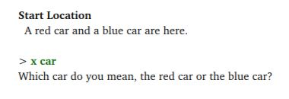traditional Hugo disambiguation

Now, occasionally, situations arise where the adjectives and nouns for several of the objects being listed match and it’s almost impossible for the player to choose the exact object he or she wants. To help with this, Roodylib also adds a numbering system to help out the player.

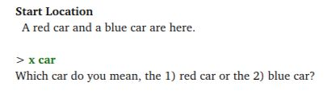Roodylib disambiguation

The player can type “1” or “2” besides any of the adjectives. “Former,” “latter,” “first,” and “second” are also accepted.
Roodylib will keep track of up to three objects to be disambiguated. If your game possibly has situations where even more might be needed, you can up the limit by declaring the DISAMB_MAX constant before Roodylib is included.
constant DISAMB_MAX 5

If, for some reason, you want to turn off the disambiguation helper completely, you can set the following before Roodylib is included:
#set NO_DISAMB_HELP

Preparse
If your game has non-default verbs, it’s likely that at some point, you’ll need to modify certain player commands and make them play nice with what the game’s grammar expects.
replace PreParse
{
local i

! Since "get off wing" or "exit wing" will cause a parser complaint
! because the player isn't really "in" the wing, change either to
! simply "exit" (i.e., to direct the library to out_to).
!
if (word[1] = "get", "climb") and word[2] = "off"
{
word[1] = "exit"
DeleteWord(2)
}
if word[1] = "exit" and ObjWord(word[2], wing)
DeleteWord(2)

! Allow handing of, e.g., "ask girl about her mother", so that "her"
! doesn't get mapped incorrectly
!
if word[1] = "ask", "tell"
{
for (i=2; i<=words and word[i]~=""; i++)
{
if word[i] = "his", "her", "your"
{
DeleteWord(i)
break
}
}
}
}
PreParse replacement in Kent Tessman’s Down

OrdersPreParse
Now, PreParse has always been in Hugo, but Roodylib adds a routine called OrdersPreParse specifically for parsing orders to characters. Here is a not-particularly-useful example:
!\ b is the word array element the command starts with and e is where it ends \!
replace OrdersPreParse(b,e)
{
if word[b] = "take" and word[(b+1)] = "break"
{
DeleteWord(b+1)
word[b] = "wait"
return true
}
return false
}
changing “CHARACTER, TAKE A BREAK” to “CHARACTER, WAIT”

preparse_instructions objects
Additionally, Roodylib has a system in place for several PreParse-esque instructions to coexist peacefully. This is mainly because several of my Hugo library extensions use PreParse for various reasons; I wanted to save authors the time of having to copy and organize everything into one routine themselves. So, if you’re writing a library extension that also uses PreParse instructions, make a preparse_instructions child instead!
! Among other things, Roodylib uses such an object to redraw the screen if it
! has changed
object parse_redraw
{
in preparse_instructions
type settings
execute
{
if display.needs_repaint
{
if RepaintScreen
RedrawScreen
}
return false
}
}
preparse_instructions object example
As a general rule, have your code return true if the command needs to be reparsed and return false if everything is fine.

Pronouns
At some point, I might try my hand at a deeper pronoun redesign, but in the meantime, you have the following updates at your disposal.

AssignPronoun
AssignPronoun is from the standard Hugo library, but previously, it was tricky for authors as Parse would always reset the wanted pronoun without some specific hackery (to be precise, you had to set the last_object global to -1). While we’re waiting for me to decide what future pronoun behavior should be, you can force pronoun setting by adding an extra true argument to its call.
AssignPronoun(<object getting a pronoun set to it>, true)
changing a pronoun

ParsePronounFix
Roodylib has a ParsePronounFix routine which tries to find an applicable object or xobject from the previous command if the action in question doesn’t apply to the current “it object”. It is called by Parse. Just add whatever game pronoun-setting rules you want in your replaced version if you need more specific rules.
routine ParsePronounFix(count)
{
local i
select word[(count-1)]
case "open","close": i = openable
case "lock","unlock" : i = lockable
case "wear" : i = clothing
case "read","peruse" : i = readable
case "activate","start","stop","deactivate" : i = switchable
case "turn", "switch"
{
if word[(count+1)] = "off","on"
i = switchable
}
if i and object is not i and it_obj = object
{
if xobject is i
it_obj = xobject
}
elseif i and xobject is not i and it_obj = xobject
{
if object is i
it_obj = object
}
}
ParsePronounFix

ExcludeFromPronouns
ExcludeFromPronouns limits what objects pronouns can be set to (I had an issue with pronouns occasionally being directed to direction objects, which I did not like). If you find pronouns being applied to objects you don’t want, you can replace this and have it check for that, too.
routine ExcludeFromPronouns(obj)
{
if obj = player: return true
#ifclear NO_OBJLIB
elseif obj.type = direction : return true
#endif
return false
}
ExcludeFromPronouns

Game Loop
I'm using this section to discuss things closely related to the process of each game turn that weren't already covered in “Parsing” (as that, of course, is also part of the game loop). Really, I had to make up something to call this section or else I'd really just be throwing a lot of information at you at once.

main_instructions
Any object within the main_instructions object has its “execute” property run after each turn (called by the Main_Calls routine, which in turn is in the main routine in a Roodyized Hugo game shell). Certain library extensions are already set up to work this way, but if you are writing your own library extension, you might want to look at this example:
object footnotemain
{
#ifset _ROODYLIB_H
type settings
in main_instructions
execute
{
FootnoteNotify
}
#endif ! _ROODYLIB_H
}

Having the above code in “footnotes.h” makes FootnoteNotify be called after every successful turn. In general, Main_Calls messages are good for the game’s system messages that should be printed after, say, game events.

NO_LOOK_TURNS
One not-often-implemented IF theory is that “look” actions (room descriptions, examining objects, etc.) should not use up a turn. Some people feel that looking should not take the same amount of game time as other actions and that it can become a frustration (especially in time-sensitive situations).
Setting NO_LOOK_TURNS in Hugo gives it this behavior, for the most part. >LOOK UNDER OBJECT still uses a turn as it implies an action along with looking.
#set NO_LOOK_TURNS
setting NO_LOOK_TURNS

Scripting
Character scripting may not be used often in Hugo games in recent years, but when I took a look at it for Roodylib, I was dissatisfied with how looping scripts wasted a turn calling the LoopScript routine.
Roodylib replaces a couple routines so that adding a true value to a character script array that calls &LoopScript will restart the script on the same turn.
setscript[Script(northgoingzax, 2)] = &CharMove, n_obj,
&LoopScript, true
the “northgoingzax” will move north every turn

Game Messages
Roodylib provides several new message-providing routines to help games look more polished. Also, adapting default messages to your game can be an important part of stylizing your game. This section covers those things.

AMERICAN_ENGLISH
I’ve had at least one betatester complain about default error messages that follow non-US rules when it comes to quotation marks and full stops.
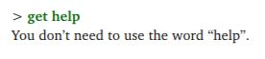 default behavior

Set AMERICAN_ENGLISH to have quotation marks in error messages follow American rules.
#set AMERICAN_ENGLISH
turning on AMERICAN_ENGLISH

AUTOMATIC_EXAMINE
I’m a fan of games that give convenience to players—ideally, without spoonfeeding the entire experience to them. Michael Gentry’s Anchorhead did a nice thing where unexamined objects automatically had their descriptions given when picked up the first time. I imagine it has shown up in other games since, but either way, I figured I’d make it easy for Hugo authors to have this behavior at the flick of a switch.
#set AUTOMATIC_EXAMINE
turning on AUTOMATIC_EXAMINE

CoolPause
In-game pauses for narrative effect have increased a ton in modern IF games since the early 2000s. It always irks me when a game is waiting for a keypress but doesn’t explicitly tell the player it is doing so. I created the CoolPause routine as a remedy for this. First off, in interpreters that support it, it uses a technique to hide the cursor so the screen just looks nicer. Secondly, it provides a “press key to continue” message to be modified to an author’s whim.
CoolPause(pausetext)
how to call
The pausetext argument is the string to be printed if you want a quick-and-easy non-default message (without replacing the &CoolPause response in the RlibMessage routine).

TopPause
TopPause is a similar routine but differs in that it puts the pause text in the status bar so it doesn’t break up the flow of the main game text.
TopPause(pausetext)
how to call
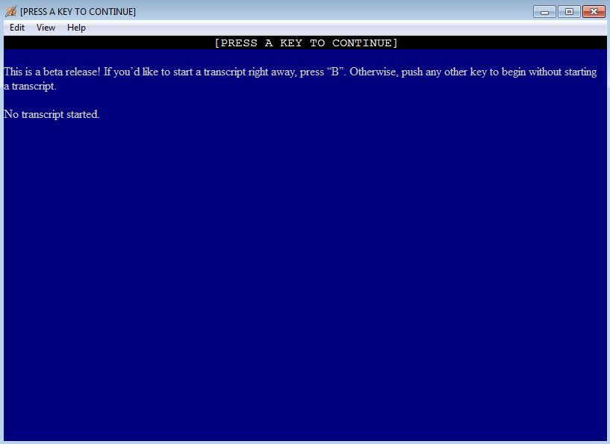TopPause() example

RoomSounds(location)
For a long time, I had difficulty coming up with a clean method of providing “room sounds” (where >LISTEN without an object would describe the room, if the location had any sounds to provide).
I eventually decided that a helper routine could solve the problem:
routine RoomSounds(obj)
{
if verbroutine = &DoListen and not object
return location
else
return false
}

In practice, this means adding this code to any room that has sounds in it.
before
{
RoomSounds(location)
{
"No sounds but the wind." ! Or whatever the sounds are
}
}
Now, listening in that room without an object will provide the expected answer.

DoVersion / GameTitle
I had a request at one point that Roodylib provide a default >VERSION response (which was a good idea since providing one largely avoids reinventing-the-wheel for each game). If your game already provides a >VERSION response, just #set NO_VERSION to turn Roodylib’s responses off.
routine DoVersion
{
print GameTitle
#if defined BLURB
print BLURB ! "An Interactive Blahblahblah"
#endif
#ifclear NO_COPYRIGHT
Copyright
#endif
PrintBanner
ReleaseAndSerialNumber
#if defined IFID
print "IFID: "; IFID
#endif
#ifset BETA
BetaNotes
#endif
#ifset DEMO_VERSION
DemoNotes
#endif
OtherNotes
}

! Roody's note: I changed TITLECOLOR to a global. Set it to something else in
! SetGlobalsAndFillArrays if you'd like to provide a special title color.

global TITLECOLOR = DEF_FOREGROUND

routine GameTitle
{
color TITLECOLOR
Font(BOLD_ON | ITALIC_OFF)
print GAME_TITLE;
Font(BOLD_OFF | ITALIC_OFF)
color TEXTCOLOR
#ifset DEMO_VERSION
print "\B (demo version)\b";
#endif
#ifset HUGOFIX
print "\I (HugoFix Debugging Suite Enabled)\i";
#endif
}
Replace these routines if you’d like to change the DoVersion text in any way

Standard Message Replacement
Roodylib continues the Hugo standard library’s method of message replacement. Since it’s such a useful thing to understand, I thought I’d give it a quick overview here. While you can always replace an entire routine in Hugo to make your changes, Hugo makes this simpler by keeping game messages in their own routine. If you want to change the “Taken.” response when an object is picked up, you don’t replace DoGet, you add a special case for &DoGet in NewVMessages.
Roodylib adds plenty of its own messages, too, kept in RlibMessage and RlibOMessage (for object class associated messages). In some instances, Roodylib adds message-routine calls to routines where there were none previously. In other cases, messages replace previous Hugo library messages, and some messages are entirely new. For the most part, you’ll have to check the applicable routine’s code to see if RlibMessage, RlibOMessage, Message, or OMessage is being called.
replace NewRlibMessages(r, num, a, b)
{
select r
case &DoHit : "You only hit grooves and mad beats."
case else : return false
return true ! this line is only reached if we replaced something
}
example of Roodylib message replacement

Resources
Roodylib now has a few additional routines for checking for the existence of resources. This way, if your multimedia-enriched game somehow gets distributed without its resource files, the game can check for the resource and then behave accordingly.

CheckResourceMusic
CheckResourceMusic checks for the existence of a particular song. If the interpreter’s op code functionality supports it, it will check without playing the song. Otherwise, it attempts to play the song for a moment at volume 0 and returns whether the attempt was successful.
CheckResourceMusic(<resource file name>,<song file name>)
how to call

CheckResourceSound
CheckResourceSound does the exact same thing for sound files.
CheckResourceSound(<resource file name>,<sound file name>)
how to call

CheckResourceGraphic
CheckResourceGraphic only works with interpreters that support the op code check method, as it’s kind of impossible to design a graphic-checking routine that will work for all scenarios.
CheckResourceGraphic(<resource file name>,<graphic file name>)
how to call

Resource Treatment in Gargoyle
The multi-interpreter Gargoyle, while very pretty when it comes to games that don’t rely upon graphics, music, or even text orientation, does this ugly thing where it rips each graphic, music, or sound file from the resource file and clogs up the game directory. Roodylib, by default, doesn’t allow resources to be used at all with Gargoyle. If you want to be nice, you can set the allow_gargoyle global variable to true. Just remember that using the PictureInText routine will not work in Gargoyle (and LoadPicture will only work in the main window).

HugoFix
HugoFix, an in-game suite of debugging commands, is immensely useful to any Hugo author. Besides the additional features we’re about to get into, Roodylib adds a pregame splash screen for turning on different kinds of game monitoring before the game even begins. We’re going to go over a couple of the newer features, but there are some we won’t cover right now (type $? in-game to get the full list)

OrganizeTree
Roodylib uses a lot of extra objects to keep track of settings and such, and the object tree can get to be somewhat of a mess and an eyesore. When HugoFix is turned on, at the beginning of the game, non-game objects are moved to applicably named objects so all of your rooms and game objects are all together, for the most part.
Roodylib also replaces the DrawBranch routine so things like display windows and fuses are easier to keep track of.
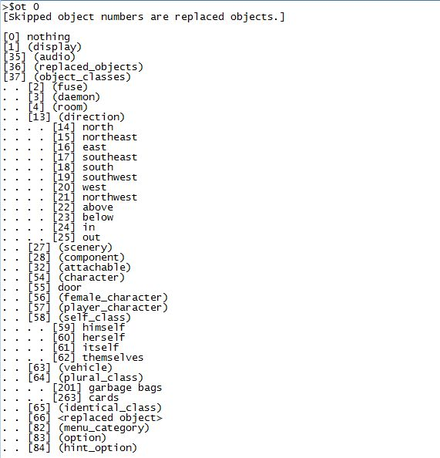 example HugoFix object tree listing

Recording Playback Helper
I use Hugo’s playback feature quite a lot when testing code. Since saved games won’t work over different compilations, there are just times when you need to repeat a lot of steps to get to a scene that you are testing. I created the recording playback helper commands to help speed up this process. Typing >$rp in a game with HugoFix on results in “Keep waiting?” prompts to be skipped. It also skips in-game pauses in anything that uses the HiddenPause routine.

Finishing Touches
Hooray, you’re almost done with your game! Roodylib can help with that, too!

Ending the Game
Just properly ending the game can involve several steps.

CallFinish
Sometimes it’s easy for new authors or authors who haven’t recently looked at the Hugo Book (or example code) to forget that to actually end the game, no routine is called. You just set the endflag global to the value you want and the game calls EndGame and prints the applicable ending text as determined by PrintEndGame.
I don’t know if this will actually help anybody, but I provided Roodylib with a routine for ending the game just for the people who can’t deny the part of themselves that says calling a routine just feels right.
CallFinish(<endflag value>)
ending the game with CallFinish

SpecialKey / SpecialRoutine
I’ve always been a fan of games with additional options when a game is won (like >AMUSING things to try). Hugo didn’t make it easy to provide these options without replacing EndGame completely, so I rewrote it to call a couple extra routines for such situations.
First off, SpecialKey looks for the proper endflag / word combination for providing the extra option.
replace SpecialKey(end_type)
{
if (word[1] = “amusing”,”a”) and end_type = 1
return word[1]
return 0
}
example SpecialKey replacement
Then you replace SpecialRoutine to do whatever you want when the player selects that choice under the proper conditions.
replace SpecialRoutine(end_type)
{
ShowPage(amusing_list) ! Example of using newmenu's ShowPage routine
! alternatively, you could just print the AMUSING list right here
}
example SpecialRoutine replacement

QuitGameText
After the player has decided he or she wants to quit the game, Roodylib provides a “Thanks for playing” message and waits for a keypress before letting the window close. I thought this was a cute effect in some Infocom games and figured it’d suit Hugo well, too.
If you don’t like it, you can just replace QuitGameText with an empty routine!

BETA system
Even if you don’t think so, your game probably needs betatesting! Setting BETA in your code before Roodylib is included provides a splash screen to compiled games asking betatesters if they’d like to start a transcript before the game has even begun. It also reminds them that prefacing their commands with an asterisk will be interpreted as a note to the author.
#set BETA
turning on the BETA system

Other Features
Roodylib has plenty of helpful routines not easily thrown under one categorization. We'll talk about some of them here.

The New Opcode System
Nikos Chantziaras has been doing a wonderful job of making it a much more pleasurable experience to play Hugo games on Linux and MacOS computers; on top of that, all ports (including Windows) are feature-complete and improve upon the original interpreters in several ways. At some point, I’ll probably include a section on making settings files to distribute along with a game to ensure it has the presentation you want. Right now, though, I’m going to talk about the new opcode system.
Nikos designed a clever way to use Hugo’s configuration file system as a way to talk to Hugor and provided several opcode values for specific behaviors (with probably more coming in the future).
Roodylib provides a opcodeterp object that it automatically gives the attribute switchedon if it detects that the interpreter is opcode-capable. If your code has some features that depend on opcode functionality, you can test for it like this:
if opcodeterp is switchedon

Additionally, at the start of every session, Roodylib checks the entirety of known opcodes and marks each available one as switchedon, so you can check the availability of a particular opcode with something like:
if open_url is switchedon

Using the Opcodes
For all of the opcodes, one calls the following routine:
ExecOpcode(opcode_file, str)

Roodylib provides several opcode objects to be used in the above routine to save authors the trouble of looking up opcode values. Additionally, some opcodes require a secondary string argument. The following list is not complete; I’m skipping some of the ones that I think are only useful for Roodylib behind-the-scenes (you can go look at the opcode section in “roodylib.h” for more information). Also, a couple will be discussed in the next section.
Roodylib opcode objects
Opcode | Description | Example:
open_url | Opens the secondary string argument in the default web browser. | ExecOpcode(open_url, “http://notdeadhugo.blogspot.com”)
fullscreen | Changes interpreter to fullscreen | ExecOpcode(fullscreen)
windowed | Changes interpreter to windowed mode | ExecOpCode(windowed)
clipboard | Copies the secondary string argument to the clipboard. | ExecOpcode(clipboard, “roodyyogurt@gmail.com”)
is_fullscreen | Returns true if the interpreter is currently in fullscreen mode | ret = ExecOpCode(is_fullscreen)

Opcode object classes
Some opcodes can be used several ways, and I find it most useful to define an object class from which authors can define certain behaviors.

fade_screen
As one might guess, the fade_screen opcode affects the transparency of all text on the screen. With it, it’s possible to make text fade in and out as you wish. Roodylib provides one example:
fade_screen full_opacity "restore full opacity opcode"
{
in fade_screen ! This isn’t really necessary
block 1 ! true if the fade should stop game code execution
! false if it should run in the backgound
duration 1 ! duration of fade, in milliseconds
start_opacity 255 ! beginning opacity of fade (0 = completely faded,
! 255 = full opacity
! -9999 = whatever current opacity is)

end_opacity 255 ! opacity at end of fade
}

The above is sort of an “un-fade.” Roodylib calls it automatically after game restarts or loads, so that if a game is currently “mid-fade”, it doesn’t get stuck in a situation where there is unreadable text. Anyhow, using those guidelines, you can create your own fade_screen objects so your fades can be as long or short as you’d like. Then you can call them like such:
ExecOpcode(full_opacity)

set_color
Hugor now lets you define additional colors to be used in games, well beyond the 16 that we have made due with in the past. First, make a set_color object:
set_color burnt_sienna "burnt sienna"
{
rgb 233 116 81 ! the rgb values
alpha_value 255 ! the opacity, from 0-255
}

You can now apply this color to any of the color numbers between 100 and 254.
ExecOpCode(burnt_sienna,100) ! applies burnt sienna to 100

Finally, your game can check if the color opcode is supported and apply colors accordingly:
if set_color is switchedon
color 100, BLACK ! burnt sienna on a black background
else
color WHITE, BLACK

Contact and Future Additions

To be honest, I did not cover everything yet in this release of the Roodylib documentation. At some point, I’d like to cover the following, too:
- “settings” objects and explanation of word array saving
- HiddenPause, GetKeyPress
- An explanation on how SpeakTo is basically a parsing routine and the steps Roodylib takes to improve its functionality

In the meantime, if you have questions about these or any other things, feel free to e-mail me at roodyyogurt@gmail.com or post a question at any of the following forums!

https://www.intfic.com/
https://intfiction.org/c/technical-development/development-systems/56
http://www.joltcountry.com/phpBB3/viewforum.php?f=8

(Let it be known that I check joltcountry.com more regularly than the others.)

